Introduction
Cerebral palsy ]CP[ is a group of motor problems and physical disorders that result from a brain injury or abnormal brain development and that may occur during fetal growth, at the time of birth, or in the first 2 or 3 years of a child's life. The brain injury that causes CP does not get worse over time, but symptoms may start, change, or become more severe as a child grows. CP affects the muscles of a part or side of the body or sometimes the entire body. Uncontrolled reflex movements and muscle tightness ]spasticity[ occur with varying severity. Physical problems of cerebral palsy range from mild ]a clumsy walk[ to severe ]an inability to control movement of the arms, legs, or muscles of the mouth and tongue[. People with severe forms of cerebral palsy are more likely to have other problems, such as seizures or intellectual disability ^{]1[}.
CP is caused by brain injury or brain malformation that occurs before, during, or immediately after birth while the infant’s brain is under development. But how a brain injury affects a child’s motor functioning and intellectual abilities is highly dependent on the nature of a brain injury where the damage occurs, and how severe it is the causes of brain injury, birth injury and brain malformation Infections during pregnancy , Severe untreated jaundice, Asphyxiation , Brain injury during or shortly after birth ,Brain hemorrhage before birth , Infections after birth , Genetic causes^{]2[}.
There are Different Types of CP: Spastic Cerebral Palsy, Athetoid Cerebral Palsy, Ataxic Cerebral Palsy, Mixed Cerebral Palsy. Spastic Cerebral Palsy is the most common type of CP, making up 70 to 80 percent of cases. People with spastic cerebral palsy often experience exaggerated or jerky movements ]hypertonia[. Spastic CP is caused by damage to the brain’s motor cortex, which controls voluntary movement. It is also caused by damage to the pyramidal tracts, which help relay signals to the muscles. This is why spastic CP is sometimes referred to as “pyramidal”. In most studies, diplegia is the commonest form ]30% – 40 [, hemiplegiae is 20% – 30%, and quadriplegia accounting for 10% – 15%. In an analysis of 1000 cases of CP from India, it was found that spastic quadriplegia constituted 61% of cases followed by diplegia 22%^{]3[}.
Spastic diplegia is the lower extremities affected more than upper-body spasticity. The most common form of the spastic forms ]70–80% of known cases [, most people with spastic diplegia are fully ambulatory, but are "tight" and have a scissors gait. Flexed knees and hips to varying degrees, and moderate to severe adduction ]stemming from tight adductor muscles and comparatively weak abductor muscles[, are present ^{]4[}. and the visual, vestibular, and somatosensory systems be have as a multisensory network that helps to maintain balance and posture, and it may be affected in patients with CP. These systems, in combination with the cerebellar and musculoskeletal systems, are controlled by the CNS and are affected by balance and movement ^{]5,6[}.
Balance is an ability to maintain the line of gravity ]vertical line from center of mass[ of a body within the base of support with minimal postural sway^{]7[} .There are two types of balance: dynamic balance is the branch of mechanics that is concerned with the effects of forces on the motion of a body or system of bodies, especially of forces that do not originate within the system itself, which is also called kinetics^{]8-10[}. Static balance occurs when the center of gravity of an object is on the axis of rotation^{]11[}. The object can therefore remain stationary, with the axis horizontal, without the application of any braking force. It has no tendency to rotate due to the force of gravity.
Children with CP have impairments that interfere with their motor function, physical activity, and social participation. Neuromuscular and musculoskeletal impairments include spasticity, poor balance, loss of selective motor control, and weakness ^{]12[}. Therefore, the focus of physical therapy for children with CP is on facilitation of functional independence in activities of daily living. Various therapeutic approaches are used to achieve the best functional condition considering the degree and types of impairments, motor abilities, psychological states, and other factors ^{]13[}.
Hippotherapy is a rehabilitation technique in which a therapist uses the characteristic movements of a horse to increase neuromuscular function in patients. This therapeutic method has been used mainly for children with CP ^{]14[}. In hippotherapy, the rhythmic and repetitive movements of a horse provide sensory input and stimulate the upper motor neurons. The pelvic movement of a horse during walking is very similar to that of humans ^{]15[}. Moreover, during hippotherapy, the body heat from the horse improves blood circulation, reduces abnormal muscle tone, and relaxes spastic muscles in CP patients ^{]16[}. Physical therapists are now recognizing the various therapeutic effects of hippotherapy.
Recently, studies have been performed to verify the effects of hippotherapy in children with CP. They report increased gross motor function score, and improved postural control and gait in these children ^{]17,18[}.
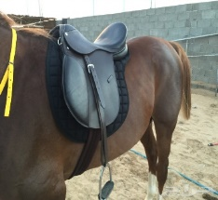
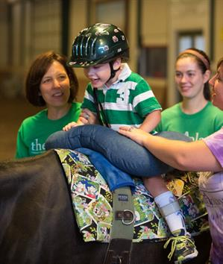
Fig. ]1 [Hippotherapy.

. ]

Statement of the problem
Does hippotherapy has an effect on balance parameters in spastic diplegic cerebral palsied children?
Purpose of the study
This study was aimed to investigate the effect of hippotherapy on balance parameters in spastic diplegic Cerebral palsied children.
Null hypothesis
There was no effect of hippotherapy on balance in spastic diplegic cerebral palsied children.
Limitation
- A lot of types of CP.
- Age.
- Variation of balance problem.
Delimitation
- choose one type of CP ]spastic diplegic[
- select the age ]7-9 years[.
- balance scale ]6[.
Significance
Cerebral Palsy is one of the most common causes of lasting disability in children. Many children with the disorder also experience sensory, communicative, and intellectual impairments and may have complex limitations in self-care functions. Care-giving is a normal part of being the parent of a young child, but this role takes on an entirely different significance when a child experiences functional limitations and possible long-term dependence One of the main challenges for parents is to manage the child's chronic health problems effectively in addition to that of coping with the requirements of everyday living. Consequently, the task of caring for a child with complex disabilities at home might be somewhat daunting for caregivers. And Parents of children with CP often experience higher levels of stress than other parents. Attitudes of people towards children with CP and the family also add up to the psychological trauma. The attitudes and stigmatization could be very disturbing. The child can be deprived of educational opportunities, recreational facilities, and opportunities to develop friendships. A good sense of self-esteem is therefore required to cope effectively and promote good mental health for the parents and care-givers.
There are a lot of studies talking about the treatments of CP and how can these methods improve the quality of life, but there are few studies talking about hippotherapy and its affect. So that, this study done to investigate the effect of hippotherapy on balance in spastic diplegic CP.

Subject, Materials and Methods

Before starting the first assessment, caregivers were requested to sign a consent from if they accepted to let their children participate in this study. This consent has been approved by the Ethics Committee of the College of Applied Medical Sciences, Sattam bin Abdul-Aziz University, Alkharj.
Study design: -
Study was a randomized controlled trial with pretest and post-test group design. The present study was conducted at king Abdullah specialist children hospital.
Subject: -
Thirty spastic diaplegic cerebral palsied children their age ranged from 7-9 years old and BMI from 15-18 kg/m². They were selected from king Abdullah specialist children hospital. To be included in this study the children should have balance scale at 6, spasticity grad 1⁺at modified ashworth scale ]appendix I[.The children were excluded in they have any of the following: mental retardation, fixed deformity at any lower limb joint, cardiac problem, chest infection, obese children.
Children were randomly assigned into two groups of an equal number. Group ]A[ study group and Group ]B[ control which received a designed physical therapy treatment, while group A ]study[ received the same program in addition to hippotheray.
All children in both groups were evaluated before and after 8 weeks of treatment for pain and balance.
Materials: -
-For assessment:
Balance biodex system.
Fig. ]2 [Balance biodex system.

-For treatment:
- Balance biodex system.
- Ball, mats, wedges, rolls of different size and Balance board.
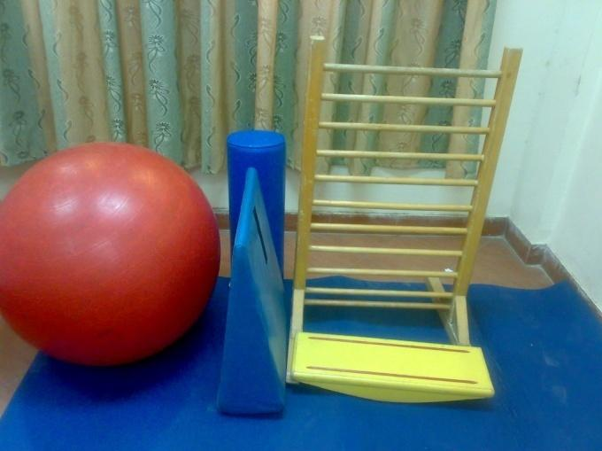
Fig. ]3[ Treatment equipment.
Methods: -
-For assessment:
Pain measurement: Pain intensity was measured using the self-report faces scale. Each child was asked to score their average pain experience using a self-report face pain scale which is valid and reliable and has good psychometric properties ^{[19]}. Measurement score was done pre-treatment procedure and after 8 weeks treatment for two groups.
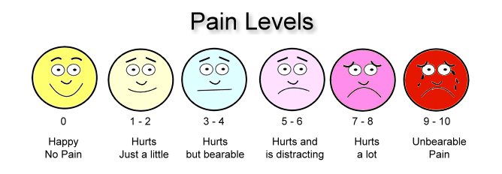
Fig. ]4[ Self-report face pain scale.

Balance measurement:
-Balance biodex system [BBS]
Biodex Stability System ]BSS[ was used to assess the dynamic balance at the Balance Lab, Faculty of Applied Medical Science, Prince Sattam bin Abdulaziz University. The BSS reliability been reported ^{[20]}. The BBS was calibrated before each measurement according to the manufacturer’s manual.
Dynamic balance test of BBS was used. It was performed on stability levels from 6. Certain parameters were fed to the device including: child’s age, weight, height, and stability level. In the two groups every child was instructed to achieve a centered position on the board once the board with the two leg stance while grasping the handrails by shifting position of feet until it is easy to keep the pointer centered on the screen grid while standing in a upright, comfortable position. Then the child was instructed that now the board will be released. Once centering is achieved on the unstable footboard and the pointer is in the center of the display target, child was instructed to maintain position and the board was stabilized. Then the foot position of the child on the foot board grid was measured. Three trials were done before testing for learning. The test began after introducing feet angles and heel coordinates into BBS, the board progressive to an unstable state, then the child was instructed to keep focus on feedback screen directly in front of her. Both hands at the side of her body and asked to maintain the pointer in the middle of on the screen. The test duration was 30 s [sec.]. The result was showed on the screen at the end of each test including overall stability index [OSI], anterior/ posterior stability index [APSI] and medial/ lateral stability index [MLSI].
-For treatment:
Patients of the both group received a designed physical therapy program for one hour sessions, three days per week for 8 weeks. This program include:

1- Facilitation therapy
1) Back and abdominal exercises to prevent spinal deformities and improve trunk control.
2) Facilitation of posture reaction including:
- Stimulation of equilibrium reaction from sitting on ball.
- Stimulation of protective reaction from sitting on ball and standing on balance board by tilting the child in different directions forward, backward and sideway.
3) Stretching exercises to maintain the optimum length of the muscle especially the tendoachilis, hamstrings, hip flexor adductors in the lower limbs.
4) Facilitation of standing and weight shift.
5) Gait training exercise.
6) Training for ascending and descending stairs.
2-Balance
The training modes provide a simple means of sitting up a training or exercise session. Five interactive game like training mode are provided include: postural stability, limits of stability, weight shift, maze control and random control. These allow for fast patient setups, less formal protocols than the testing routines and the ability to change stability levels from very unstable to static during the training session.
For our samples we decided to use the limits of stability ]IOS[ training routine. The Limits of Stability Training screen is designed to challenge the user to move through a movement pattern consistent with the sway envelope. The sway envelope is that area a person can move their center of gravity ]COG[ within their base of support.
3-Hippotherapy
Children in the hippotherapy-plus-physiotherapy group received 30 minutes of hippotherapy, three days per week for 8 weeks ]24 sessions[ in addition to a designed physiotherapy. Sessions were conducted by physical therapists with extensive training in hippotherapy. Horses worked during sessions with a trained experienced horse trainer. Two volunteer side walkers walked along either side of the horse, assisting participants. Two participants were grouped together for each session.

A fleece soft saddle was selected instead of a regular English riding saddle to maximize contact between participants and the pony. For safety, all participants wore safety helmets for protection.

The 4 ponies were trained by the staff to participate in the program. Ponies and participants were matched according to size and functional status of the children to size and movement characteristics of the ponies as best as possible.

We used the hippotherapy treatment protocol described in the study by McGibbon et al, which included muscle relaxation; sustenance of optimal postural alignment of head, trunk, and lower extremities and independent sitting; and active exercises ]stretching, strengthening, dynamic balance, postural control[ directed by the therapist. Intensity of the exercises was modified to each participant's ability to effectively facilitate postural control. Participants were encouraged to maintain postural alignment while performing all activities with necessary assistance from the side walkers.
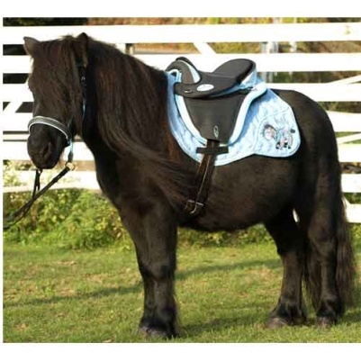
fleece soft saddle

Data analysis: -
SPSS version 19 was for statistical analysis, descriptive statistics were used to summarize the demographic data. Independent t-test was used to investigate the differences between age, height, weight and BMI between two groups, also it was used to differentiate the differences between two groups regarding the outcome measures. While, within group, paired t test was used to clarify the differences between pre-test and post-test. Statistical significance was accepted at the ]0.05% level[.
Fig.]5[Fleece soft saddle and English saddle.

Results
Thirty spastic diaplegic cerebral palsied children. Their ages ranged between ]7-9[ years old, height ranged ]130-140[ cm, weight ]35-45[ kg. They were selected from king Abdullah specialist children hospital, evaluated before and after 8 weeks of treatments by balance biodex system and self-report face pain scale.
There were no significant differences between baseline characteristics ]age, height, weight, BMI [ between two groups before treatment.
Table ]1[: Represent the demographic data for both groups ]study A, control B[.
Variables | Study ]A[ | Control ]B[ | P value | Significance
Age]ys[ | 8 ± 0.8 | 7.9 ± 0.9 | >0.05 | N.S
Height]cm[ | 137 ± 2.4 | 138 ± 2.5 | >0.05 | N.S
Weight]kg[ | 40.3 ± 2.4 | 40.7 ± 2.7 | >0.05 | N.S
BMI ]kg/m²[ | 15.1 ± 1.5 | 15.3 ± 1.9 | >0.05 | N.S
N.S: no significance. Ys: years.
Kg: kilogram. Cm: centimeter.
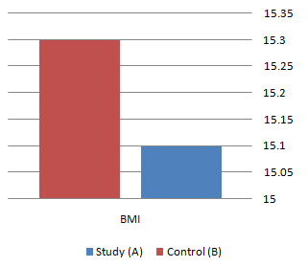
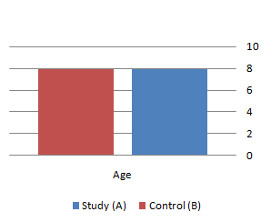
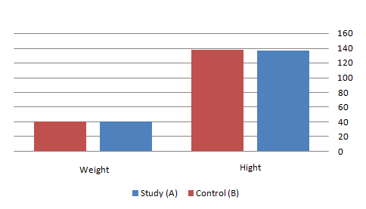
BMI: body mass index.

Fig. [6] Demographic data for both groups ]study A, control B[.
There were no significant differences between pre treatment variables ]pain, balance, parameters[ between both groups.
Table ]2[: Pre treatment data for both groups ]pain , OSI , APSI , MLSI[.
Variables | Study ]A[ | Control ]B[ | P value | Significance
Pain score | 6.7±0.79 | 7±0.8 | >0.05 | N.S
OSI | 2.01±0.06 | 2±0.05 | >0.05 | N.S
APSI | 1.98±0.06 | 2±0.07 | >0.05 | N.S
MLSI | 1.45±0.05 | 1.39±0.06 | >0.05 | N.S
OSI: overall stability index. APSI: anterior/ posterior stability index.
MLSI: medial/ lateral stability index. N.S: no significance.
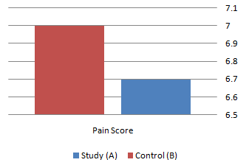
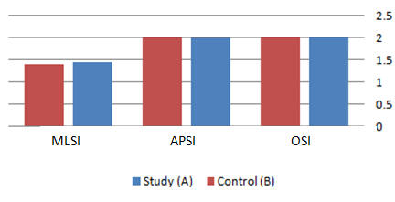
Fig. [7] Pre treatment data for both groups ]pain , OSI , APSI , MLSI[ .

There were significant differences of pain score and balance parameters between pre and post treatment in study group.
Table ]3[: Pre-Post treatment data for Study ]A[ ]pain , OSI , APSI , MLSI[.
Study ]A[
Variables | Pre | Post | P value | Significance
Pain score | 6.7±0.79 | 5±0. 88 | <0.05 | S
OSI | 2.01±0.06 | 1.91±0.15 | <0.05 | S
APSI | 1.98±0.06 | 1.85±0.08 | <0.05 | S
MLSI | 1.45±0.05 | 1.35±0.09 | <0.05 | S
OSI: overall stability index. APSI: anterior/ posterior stability index.
MLSI: medial/ lateral stability index. S: significance.
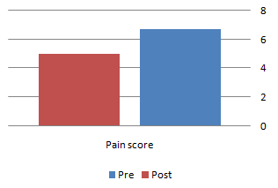
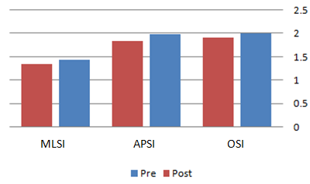
Fig. [8] Pre-Post treatment data for study ]A[ ]pain , OSI , APSI , MLSI[.

There were significant differences of pain score and balance parameters between pre and post treatment in control group.
Table ]4[: Pre-Post treatment data for Control ]B[ ]pain , OSI , APSI , MLSI[.
Control ]B[
Variables | Pre | Post | P value | Significance
Pain score | 7±0.8 | 6±0.79 | <0.05 | S
OSI | 2±0.05 | 1.94±0.10 | <0.05 | S
APSI | 2±0.07 | 1.91±0.11 | <0.05 | S
MLSI | 1.39±0.06 | 1.36±0.10 | <0.05 | S
OSI: overall stability index. APSI: anterior/ posterior stability index.
MLSI: medial/ lateral stability index. S: significance.
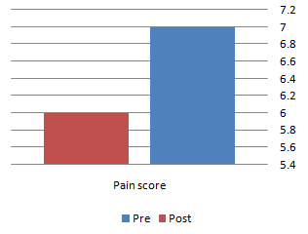
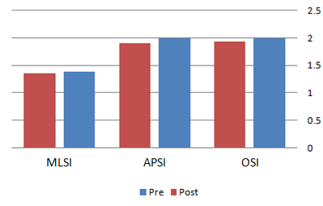

Fig. [9] Pre-Post treatment data for Control ]B[ ]pain , OSI , APSI , MLSI[ .

There were significant differences between post treatment variables of both groups in favor to study group.
Table ]5[: Post treatment data for both groups ]pain , OSI , APSI , MLSI[.
Variables | Study ]A[ | Control ]B[ | P value | Significance
Pain score | 5±0.88 | 6±0.79 | <0.05 | S
OSI | 1.91±0.15 | 1.94±0.10 | <0.05 | S
APSI | 1.85±0.08 | 1.91±0.11 | <0.05 | S
MLSI | 1.35±0.09 | 1.36±0.10 | <0.05 | S
OSI: overall stability index. APSI: anterior/ posterior stability index.
MLSI: medial/ lateral stability index. S: significance.
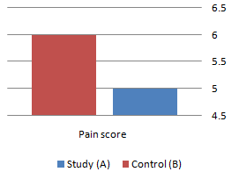
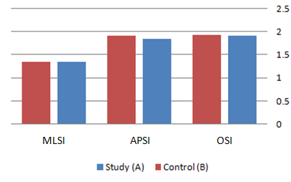
Fig. [10] Post treatment data for both groups ]pain , OSI , APSI , MLSI[.

Discussion
Balance control is very important for children with CP, and maintaining balance requires three distinct sensory system inputs: visual, somatosensory, and vestibular^{]21[}. Generally, the dynamic sense of balance depends primarily on vestibular input on unstable surfaces; however, static balance primarily depends on somatosensory input^{]22[}.
In this study, thirty diaplegic cerebral palsied children. Their ages ranged between ]7-9[ years old, height ranged ]130-140[ cm, weight ]35-45[ kg. They were selected from king Abdullah specialist children hospital, children were randomly assigned into two groups of an equal number. Group ]A[ study group and Group ]B[ control which received a designed physical therapy treatment, while group A ]study[ received the same program in addition to hippotheray. All children in both groups were evaluated before and after 8 weeks of treatment by balance biodex system and self-report face pain scale.
The results showed a decrease in pain score and a decrease in OSI, APSI and MLSI, which represents balance. Therefore, the results indicate improvement in balance after hippotherapy intervention, particularly after 24 sessions.
There are no available data related to the effect of hippotherapy on pain in spastic diaplegic CP. Therefore, we have come to other studies in a relationship hippotherapy to decrease pain. The findings of this study were similar to the results of in study Hakanson et al. ]2009[, conducted a research to evaluate the effectiveness of hippotherapy in 24 patients having neck pain and backache causing restrictions to their daily life. They found that hippotherapy provided a relaxing effect on their pain complaints and on other symptoms apart from pains and also it had a therapeutical effect on patients’ body image. ^{[23]}
Also, that comes in consistency with Yoo et al. ]2014[, conducted a research to examine the effects of horseback riding simulator on pain and body power in patients having chronic backache. The study was conducted with the participation of 47 male patients by randomizing patients into treatment and control groups. While the patients in treatment group conducted horseback riding exercise with a horse simulator for three times in a week during 8 weeks period, the patients in control group did not take any physical alternative treatments. Pain evaluation of the patients was carried out via Visual Analog Scale ]VAS[. After 8 weeks, the pain level of the patients in treatment group decreased more than the pain level of the patients in control group and their isokinetic body movements were improved. At the same time, it was found with measurements that muscle mass of the patients in treatment group has increased more and their fat mass has decreased more than the patients in control group. ^{[24]}
And in other countries, the number of the studies examining the effects of hippotherapy on pain managements is pretty low, however there are studies showing the positive effects of hippotherapy on certain types on pain.
Children with CP often show restricted trunk and hip movement, and the fixed antero or retroversion pelvic position is mobilized by the horse’s movement^{]25-27[}. The trunk and hip movements generated when riding may affect balance and coordination ^{]25-28[}.
The opportunity to actively practice posture strategies and balance in changing environments might promote automatic postural reactions, anticipatory response, and posture control feedback. These anticipatory posture adjustments, known as feedforward, are necessary for postural balance and depend on practice and experience with the task and the environment^{]29[}. Therefore, hippotherapy might be useful in promoting this type of training because the child is continuously responding to a changing environment, which stimulates these adaptive behaviors and movement strategies.
This need to adjust to periodic changes in the horse’s body position with changes in trunk conformation demands the use of muscles and joint movements, which might lead to increased strength and range of motion ^{]30[}. Repetition of these adjustments during hippotherapy sessions promotes strengthening of pelvic, abdominal, and lumbar muscles, factors that contribute to improved trunk balance and posture control ^{]31,32[}.
The activities selected for the protocol and the riding instruments may have contributed to the improvements in the individuals’ balance and functionality. The blanket was selected because it provides greater contact with the horse and allows for greater perception of the animal’s displacement and greater recruitment of trunk muscles^{]27[}. Stretching activities while performing tasks such as touching the horse’s or the child’s own body involve crossing the body’s midline, which improves positioning in children who have difficulty with this skill; it also demands balance and posture control^{]27,33[}. Zigzag movements, changes in the frequency and amplitude of the horse’s gait, and variation in the individuals’ position on the horse create different physical challenges and modify the proposed stimulation, thus generating anticipatory and straightening-up reactions, enhancing the vestibular system and motor coordination action, and strengthening muscles. When changing position on the horse, different motor units are being recruited. Terrain variations such as sand, asphalt, and grass most likely activate the baroreceptors and stimulate proprioception^{]25-27,34-36[}. The blindfolded activity performed in the present study has been used to overcome limits and promote greater stimulation of the vestibular and proprioceptive systems, inducing an automatic trunk reaction ^{]27[}.
Şık et al. ]2012[ conducted a randomized controlled study in which they aimed to reveal the effects of hippotherapy on gross motor functions, balance, coordination and walking in children with cerebral palsy. 23 children with spastic CP were included to the study and divided into two groups as hippotherapy and control randomly. While applying the total of two week one-hour sessions conventional physical therapy program to all children in both groups, hippotherapy group also received 30-45 minutes hippotherapy training 1 time per week for 10 weeks. As a result of the study; it was found that the rates of total lying-rolling, crawling-kneeling, standing, gross motor function development scores were significantly higher than the control group and it was seen that in the kids in this group had statistically significant increase in their walking speed and cadence functions. In the same study, it was stated that the hippotherapy could be evaluated as a useful method to provide additional motor gains in the rehabilitation and treatment of children with CP ^{]37[}.
Other studies reported improvement in dynamic balance measured with the BBS in children with CP^{]38,39[}. the horseback riding simulator could be a useful alternative to hippotherapy for improving of static and dynamic balance of children with CP. The hippotherapy may be a viable strategy for reducing balance deficits and improving the performance of daily life skills in children with mild to moderate balance problems.

Conclusion
We concluded that hippotherapy is effective in balance improvement. So that hippotherapy can be added safely to the program of spastic diplegic cerebral palsed children.

Recommendation:
- Further studies are needed to elucidate the effectiveness of hippotherapy for other types of CP.
- Further studies are needed to elucidate the effectiveness of hippotherapy for Down syndrome.
- Further studies are needed to elucidate the effectiveness of hippotherapy for Autism syndrome.
- Further studies are needed to elucidate the effectiveness of hippotherapy for Gait dysfunction and Back geometry in CP.

